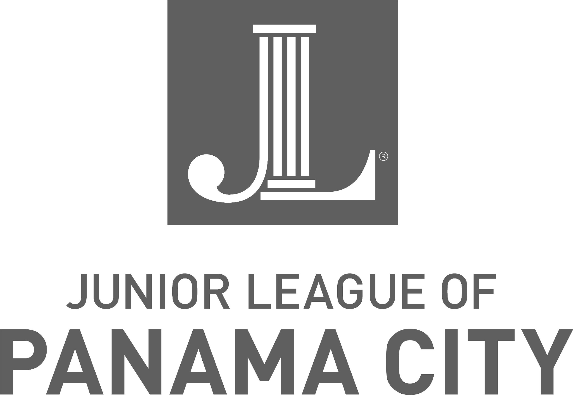
Junior League of Panama City
M Membership Application, 2022-2023 League Year

Biographical Information

Last Name __________________________ First ______________________ Maiden _____________________

Street Address _______________________________________________________________________________

City ____________________________ State ____________________ Zip Code ________________________

Home Phone _________________Cell Phone ___________________ Email ____________________________

Birthdate _____________ Marital Status ____________ Spouse’s Name _______________________________

Education (for informational purposes only, not a requirement of membership)

College or University __________________________ City _________________________ State _________

Major:_______________________________________________ Degree _________________________________

Graduate School___________________________________City _________________________ State ________

Major_______________________________________________Degree __________________________________

Employment (for informational purposes only, not a requirement of membership)

Name of Employer ___________________________________________________________________________

Position/Title _______________________________________________________________________________

Civic Involvement (for informational purposes only, not a requirement of membership)
Please list other organizations, including professional and civic, in which you are a member.

_____________________________________________________________________________________
_____________________________________________________________________________________
_____________________________________________________________________________________
_____________________________________________________________________________________
_____________________________________________________________________________________

How did you learn about the Junior League of Panama City?

_____ JLPC Website ______ Association of Junior League International_____ Referral _____ News Media

Community Event (please describe) _______________________________________________________

If applicable, please list the name(s) of the person(s) who introduced you to the League.

____________________________________________________________________________________________

As a New Member of the Junior League of Panama City, I understand that New Members are those members who are engaged in training established by members to prepare them for effective community and League membership. I agree to meet the following obligations and responsibilities:
- Attend the New Member Retreat (date and location TBA).
- Attend a minimum of 8 of 10 monthly New Member Trainings. New Member training will be held once a month. No more than 2 absences are permitted.
- Attend a minimum of 6 of 8 General Membership Meetings. No more than 2 absences are permitted. These will also be the 1st Tuesday of the month following the New Member Training.
- Complete all New Member Course assignments, including the New Member Project to be determined by your class and the Board of Directors.
- Pay a non-refundable New Member course fee of $50 with your application and New Member dues for the current League year of $150 at your Retreat. (Also includes Holly Fair T-shirt, name tag, and national league dues)
- Participate in three League-wide Events (i.e., Holly Fair Preview Party November 10th, Holly Fair Shift (November 10th-13th, 5K Race Series and Bunrch Feast etc.)
- Submit to a criminal background check every two years due to the involvement with children and the elderly in many of our JLPC placements & events.
I understand that as a New Member of the Junior League of Panama City, I must fulfill these obligations and responsibilities in order to be in good standing and to be granted Active status. I also understand that these obligations may be altered somewhat between now and June 1, 2022.

Signature of Applicant _______________________________________________________________________

Applications for the 2022-2023 New Member Class must be received by June 18, 2022.
Checks should be made out to the Junior League of Panama City.

Please send your completed application, together with your New Member Course Fee of $50, to
Junior League of Panama City, Attn: Katherine Waller, 736 Jenks Avenue, Panama City, FL 32401
For questions, please contact Katherine Waller at khamrick90@gmail.com

The Junior League of Panama City is an organization of women committed to promoting volunteerism, to developing the potential of women, and to improving the community through the effective action and leadership of trained volunteers. Its purpose is exclusively educational and charitable. The JLPC reaches out to women of all races, religions, and national origins who demonstrate an interest in and commitment to volunteerism.

